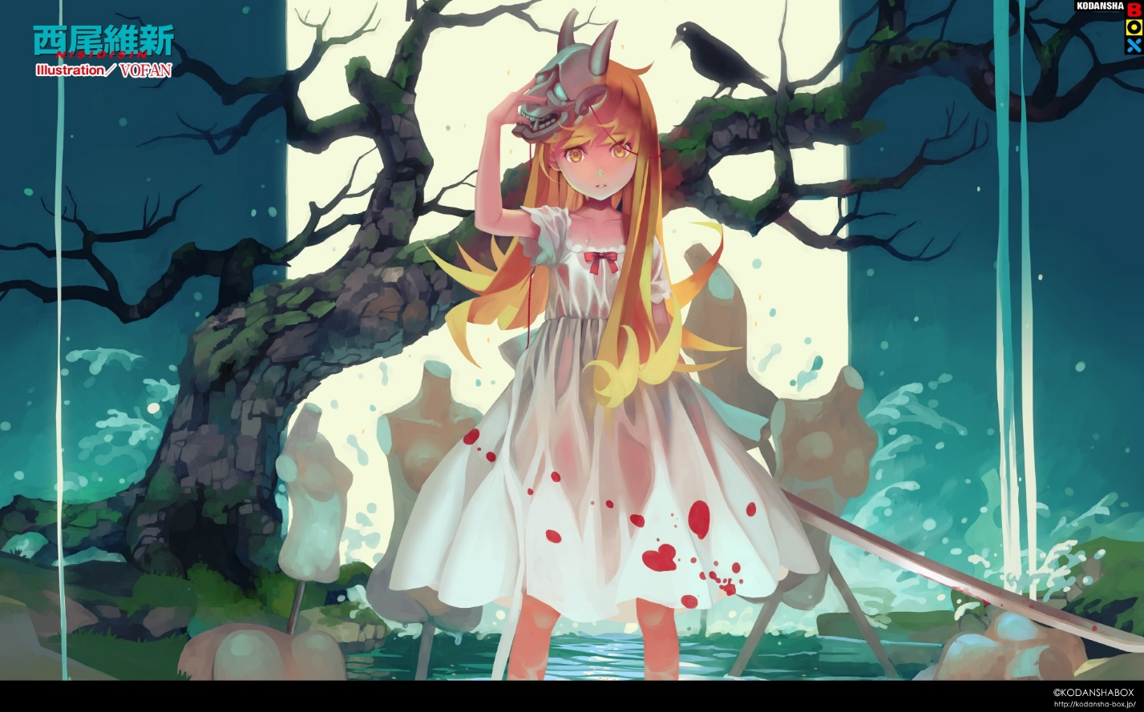Shinobumonogatari

# Shinobu Mustard

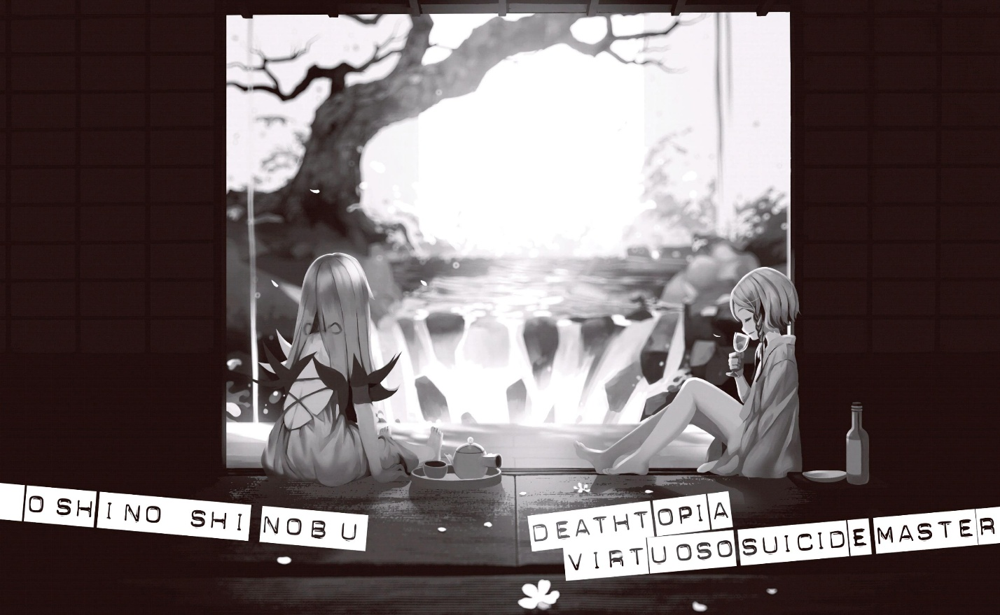Chapter 47  
p. 252-265

While Koyomi Araragi was receiving an entirely hopeless, yet amusing, reply from Seiu Higasa—“I don’t have a bicycle, but I *do* have a unicycle”—a blond, golden-eyed high school girl succeeded in infiltrating the Japanese mansion that the college student and the specialists’ boss had departed together in said college student’s car; it was almost like they had passed right by each other.

Nude but for a jet-black cloak, the blond, golden-eyed high school girl wasn’t even wearing shoes. She tried to enter the interior of the mansion without getting permission from the head of the household, but a voice called out to her from the garden.

“Hey, hey. Over here, not in there. Long time no see, high school girl. Glad to see you’re doing well.”

She turned around. Atop a very fancy rock, in a very fancy garden the point of which she didn’t really understand (she had recent been totally absorbed by basketball), was the little girl she had encountered about one week prior.

The blond, golden-eyed girl.

Her name was Deathtopia Virtuoso Suicide-Master—the death-prepared, death-inevitable, death-certain vampire; the ancient vampire.

The same person who had made her into a vampire.

No—the same demon.

“…You seem well, too. Didn’t I bury you?”

Without showing much surprise, the blond, golden-eyed vampire asked the little blond, golden-eyed girl, who was for some reason exposing herself in handsome white clothing.

Well, she’s an immortal vampire; there’s no reason to be astonished that she came back to life.

But this pattern was ironic.

The little girl clad herself in the white clothing in the same manner as she had clad herself in her black cloak—perhaps that is what it means to be a “master” as a vampire.

Master—Suicide-Master.

“Indeed. Somehow or other, it seems I died again. ‘Cause I drank your blood—no, your poison, you know. My goodness, I’ve really gone decrepit. To think that I can’t even drink human poison anymore…”

“Don’t make it seem like my fault. You just died on your own; I didn’t kill you, did I? All I did was bury you.”

“You didn’t just bury me. After that, you took up my name of all things and did whatever you pleased with it, isn’t that right? Thanks to you, I was forced to take responsibility for an eat-and-run, and everything’s been hectic. I just want to go home, but I’m being detained here.”

Her words were quarrelsome, but it didn’t seem like she was particularly angry about having her name used in that way. Rather, the little girl seemed to be enjoying the adversity.

An enviable sensibility.

*If I had one thousandth of her sensibility, one year of her millennium, I don’t suppose I’d have felt so vile in that club—I don’t suppose it would have turned out like this.*

It appeared that despite becoming a vampire, that aspect of her character had not been “optimized”. *Or perhaps, even in its best form, this is simply the limit of my character.*

“Even if it was for the purpose of derailing the investigation, I do feel bad about using your name without asking. But I didn’t bury you in that mountain out of malice, you know?”

The blond, golden-eyed high school girl spoke honestly.

“I mean, I’m grateful to you. I had intended to give you a burial.”

“A burial? Ah, I see. That’s what it was. Interment, huh.”

The blond, golden-eyed girl laughed, “Ka ka!”

“But why did you pick that mountain? That’s not where I sucked your blood. It’s not even nearby.”

Pondering why the girl was concerned with such a small detail, she answered frankly.

“I’d heard there was a shrine at the top of that mountain. North… *Something* Shrine. If I had to bury you somewhere, I thought it’d be better to hold the service close to a shrine… But still, if I said I had absolutely no intention of hiding you by burying you, that might be a lie? And I couldn’t just leave you there after you’d turned into a mummy.”

“No, no, I really don’t mind. Thanks to your half-assed concern, I actually think I was discovered faster.”

“…?”

“By the way, I asked the person who first discovered my body to excuse herself for the time being. Since I failed in sucking your blood, it’s hard for me to call you my minion, but even so, I can still sense when you’re nearby. Unlike the completely independent Kiss-Shot.”

She was stumped by the incomprehensible things the little girl was saying with that oddly foppish smile.

“Does that mean you have something to talk about with *me,*Suicide-Master? Could it be that thing again, about 'thank you for the meal’ and 'thank you for the food’ and stuff—”(1)

Although she feigned apathy, the topic itself was actually of great interest to her, as a girl who had fallen victim to the predations of club activities—so whenever she launched herself upon her crimes, she had put it to good use.

Her flabbergasted teammates’ faces were quite the sight.

“If there’s something you’d like to ask—”

“Nah, I have nothing to ask you. I’ve heard the gist of what you’ve done from the former minion of the former Heart-Under-Blade… He seems like a rather promising guy, but he’s got a bad habit of easily letting his guard down around anyone; all I had to do was play the fool, and he told me everything. Even someone like me.”

“……”

The former minion of the former Heart-Under-Blade.

The blond, golden-eyed high school girl surmised that referred to the alumnus Koyomi Araragi.

She had managed to lay her hands on a certain degree of information from the specialist’s investigation, but it wasn’t the full picture, and just one week ago, she hadn’t even known about this world’s existence until she encountered the blond, golden-eyed little girl; she didn’t have the ability to analyze the information she’d acquired.

She could only guess the details, and had no assurance that her guesses were right—but somehow or other, it seemed true that that famous *senpai* was a vampire.

“What, then. So you don’t have a question, you have a complaint?”

“I don’t have a complaint, but I *am* displeased. To think a bearer of my *tough, cool* blood would be striding the streets at night for such an *uncool* reason like revenge.”

*Is that what you wanted to do?*

*Is that why you became a vampire?*

Speaking in an amused tone, quite contrary to the words she was saying, the blond, golden-eyed little girl raised her chin up.

“You wanted to become a vampire because you wanted to do stuff like that? *Is that why you wanted me to eat you*?”

“……”

“Oh, I haven’t told the people who are after you about that yet. I have no intention of covering for you, but I sucked your blood in order to put on airs for my old friend. Well… After talking to her it seems she was trying to do the same thing for me, and to say it like you might, it’s not like I had absolutely no feelings of that sort myself.”

*In any case.*

*I haven’t told them that when I simply asked you for directions, you suddenly prostrated yourself in front of me and begged me to “make you a vampire”—*the little girl continued condescendingly.

That must be her personality; however, it irritated her. The same feeling that she always had when she participated in club activities.

Or maybe it was like her rebellious period, when she’d cried to her mother when she was a human, “I never asked you to give birth to me!” But then again, the blond, golden-eyed high school girl had prostrated herself before the little girl and begged her to *give birth to her*.

“It’s not like I was fasting in order to stay faithful to Kiss-Shot—to Princess Acerola—so I had no real reason to refuse the request. I was feeling so carefree that it didn’t really matter if I failed. But I never expected that I’d end up turning into a mummy. Even after living for a thousand years, unexpected things still happen, you know?”

Even if you live for a thousand years, huh.

So it’s perfectly natural for a teenager too—or possibly, it gets more natural the longer you live.

The blond, golden-eyed high school girl was sick of imagining that—so sick of it she’d rather die, despite at present being immortal.

“…Is that unusual, then? People like me. Fools who ask to be made vampires of their own volition. Fools who do it without even making a pretense.”

“Not entirely. There was another one, six hundred years ago. Ka ka—maybe I remembered that and got all sentimental.”

“Sentimental…”

Vulnerable.

“The former minion of the former Heart-Under-Blade seems to have a bunch of tedious opinions about the issue of eating—but if you ask me, he’s missing the crucial point. He’s only considering it in terms of eater, eaten, perpetrator, victim; it’s not so big of a problem that I had to point it out, but from my view, having lived for a thousand years, it’s too shallow.”

*In his assumptions about the person being eaten…*

*He’s left out the possibility that the one being eaten*wants *to be eaten*.

The little girl stuck out her tongue.

“Maybe it’s easier to understand if I explain it using plants. You know bananas? It’s a fruit structured in such a way that no matter how you look at at, it seems like it exists only to be eaten by you primates. It’s compact, it’s easy to hold, it comes with a wrapper, and it’s full of nutrients. You can even rely on it for a punch line where someone slips on the peel.”

“So you’re saying the banana wants to be eaten?”

You’re saying me asking to become a vampire means I’m a banana?

That’s the same reasoning as saying that it’s not cruel to eat livestock because they’re born for the sake of being eaten—or possibly the same as saying without a doubt that castrating a pet is for the pet’s own sake.

You need some doubt, even if it sounds childish.

“Why do flowers bloom so beautifully, why do they produce such sweet nectar? High school girl. To spread their pollen, right? Fruits taste good in order to spread their seeds, right?”

“But that’s just plants, isn’t it? Surely there’s no animal that wishes for itself to be eaten.” *Only something like me.*“I don’t believe there are any.”

“Really? Don’t you think there are worms and such that take their shape for the sake of being eaten?”

“I don’t eat worms.”

“Ah, is that so. It’s good to have likes and dislikes. And things you’re particular about. Even disliking things you haven’t eaten yet. But there are lots of people who go off making themselves unfortunate of their own accord, right? I’m talking about people who drive themselves into a corner, who get hurt of their own accord.”

“That’s…” *Only someone like me*. “Even if there are people like that, I still can’t believe there’s a creature that would willingly wish to be eaten.”

“I said, there was one, six hundred years ago. A creature—a human, like that. A princess like that. Though, unlike you, she didn’t want to become a vampire for disgraceful purposes like revenge and grudges. She tried to become a vampire with lofty ideals that a tough and cool vampire like me couldn’t understand—unlike yours, her reasons were exceptionally *productive*.”

“……”

Not stillborn—is that what she’s trying to say.

“Now that I see she’s completely forgotten and utterly lost those lofty ideals, it seems as though she’s accomplished them. I’m relieved from the bottom of my heart. How about you? How does it feel to do what you set out to do, eating those humans using your mighty power?”

Being compared with a forbear she’d never even met, the blond, golden-eyed high school girl felt as though she’d been seen through.

She felt absolutely no sense of accomplishment.

Rather, she felt empty.

Revenge is a futile thing—she’d never thought those cheap words would turn out to be the truth.

From the bottom of her heart, she was empty.

Dried up, like a mummy.

However, she couldn’t quit.

Right.

In the first place, she hadn’t done what she’d set out to do.

That’s why she’d slipped past so many sets of eyes to come here—to *do* it.

“Slipped past? Don’t use such a showoffy turn of phrase, high school girl—you plotting to make me die of laughter? Making plans, playing tricks, weaving facts with falsehoods, darting about from place to place like a cockroach, and finally coming here in secret. As far as the 'living’ part goes, the cockroach is superior to you.”

“…That’s right. In that regard, it was disappointing. A letdown. I’d thought vampires were better than this. Really, being weak to the sun is just the worst, isn’t it?”

She’d intended to be sarcastic, but the blond, golden-eyed little girl didn’t seem to heed it. Far from it; her attitude was full of composure.

“Yeah. We’re not all that great. It’s continuous stoicism, like a diet. These past thousand years, I’ve darted around in secret from place to place just like you—and I got captured, as if it’s time for me to pay the piper. I called you disgraceful, but I’m just as disgraceful myself.”

“…Don’t dishearten me like that. I wanted you to play up the good parts of being a vampire. If you’d like, I can prepare a whiteboard for you? You can give a presentation aimed at young people who will very soon have the right to vote, *Ten Reasons Why You Should Become a Vampire*.”

“You’ll never have the right to vote, you know. And what you’re feeling now isn’t disappointment, it’s despair. As befits the walking dead.”

“The non-walking dead… you mean it’s better to be a mummy?”

Naturally, it brought to mind the former teammates she had attacked—although she’d never thought of those girls as *teammates*.

Just when her feelings turned gloomier than the dark of night, the blond, golden-eyed little girl voiced a proposal.

“I have good news for a desperate girl like you. Nothing good about being a vampire, but good news nonetheless.”

“Good news? Like a good story?”

“Vampires don’t get good stories. If I had to say, this is a business proposal. In other words, it’s not so much good news, as it is a good offer.”

“Tell me.”

She snapped back, immediately.

It seemed she wouldn’t be able to achieve her goal in coming to this Japanese mansion—but it would be annoying to be turned away and go back empty-handed.

The investigators were steadily closing in on her.

It’s only a matter of time before a cockroach gets crushed.

She wouldn’t deny that she had drowned in the mighty power she had obtained following her supplication, but even so, but she wasn’t such a fool as to be unable to objectively judge the situation she was in.

She’d had good grades. Until she’d joined the girls’ basketball team, that is.

“What’s the good offer?”

“Go ahead and eat me.”

The little girl spoke without putting on any airs.

“If you wish to return to being human, you can suck up all my blood. Since I’m the one who turned you, that will let you go back to being human.”

“Did I say anything about wanting to turn back into a human? I know I said it wasn’t a good thing to be a vampire, but I don’t recall saying it was a bad thing either?”

“You said it was *the worst*, didn’t you?”

“A figure of speech. Please don’t find fault with my Japanese. And I don’t recall saying being human was all that great—or that being a high school girl was all that great, either.”

“If that’s what you think, don’t just suck my blood; eat my whole body. Bite and break, down to my flesh and bones. By killing your master, you’ll obtain more power than what you have now as an incomplete vampire. Uh, what was it? Like in smartphone games… Leveling up?”

Not lacking for kindness, she gave an example that a teenage youngster would find easy to understand; however, a vampire talking about smartphone games is a bit, well…

Somehow, it seemed this hungry, gourmet, dandy vampire was bad at giving presentations.

“Either way, there are no drawbacks for you. If you want to go back to being human, you can go back to being human. If you want to become a more powerful, more dreadful vampire, you can become a more powerful, more dreadful vampire—at the very least, you won’t have to scurry around secretly as much as you do now. So, what’ll it be?”

“…So is there anything in it for you? In this good news. In this good offer. In this business proposal.”

The two options seemed to call for a decision to be made as soon as the question was posed, but the blond, golden-eyed high school girl carefully delayed answering. The offer was too good to be true—rather, it was suspicious.

It almost seemed unappetizing—she oughtn’t eat it up without scrutiny.

“Whether I drink your blood or eat you, basically, that means you’ll die. Despite living for a thousand years, being *tough* and *cool*, you’ll die. What the hell? Self-sacrifice, is that it? The death-prepared, death-certain, death-inevitable vampire is going to die for just *my* sake?”

“Of course not. The basis of a business proposal is that it kills both birds with one stone, right?”

Even with her falling language grades she knew that “killing two birds with one stone” didn’t mean that both parties benefited from a deal, but it would be childish to find fault with the freedom of expression of a vampire who’d come all the way from overseas.

“Even if you don’t drink my blood or eat me, I’m going to die anyway. Like this.”

“If things keep up like this, you mean?”

“No, I’m going to die. No ifs. Whether I do something or do nothing, I’ll die. It appears I’m at my limit. I could easily have fallen into truly eternal sleep when your poison turned me into a mummy—if you hadn’t buried me where you did, I would have. By divine arrangement—or maybe, by Heaven’s grace—I’ve swollen up again, true. But in the end, this is like a dream on the verge of death.”

“You talk like you’ve drunk water from the Sanzu River.”(2)

“Quite right. The water of a mirage.”

For some reason, the frivolous talk flowed readily.

Really, what was it she drank?

“I’ll starve to death. I’ll die of anorexia. Wouldn’t that be *super* uncool? That’s why I want you to kill me—*this time*, I want you to kill me. I want you to kill me once more.”

“……”

“Truth be told, I’d thought about asking the former minion of the former Heart-Under-Blade to do it, but he didn’t seem to be the right kind of person. Just when I’d reluctantly switched over to negotiating my escape from this country, your arrival here gave me some hope. Hope, even for a desperate vampire.”

“So, you want to commit suicide? Like, the cause of death for eight out of ten… or nine out of ten… vampires is suicide, right?”

Since it was a hypothesis she’d produced by independently analyzing the internal information she’d obtained, she wasn’t very confident in it, but somehow, it appeared to be at least half correct.

“Yeah. We all commit suicide,” she agreed. “Both Kiss-Shot and her first minion wished for their own deaths in this country. But if you ask me, suicide is even more uncool than anorexia. It’s not remotely suitable for the conclusion of my *tough* and *cool* story.”

*That’s why.*

*I want to be killed before I start wanting to commit suicide.*

“So you want assisted suicide—er, euthanasia?”

“I want to die with dignity. That’s the only way to die that suits my pride. Dying nobly, and harshly. I did pretend to still be vigorous, hale, and hearty with Kiss-Shot—but I was putting up a front.”

*This is the end*.

Said the blond, golden-eyed girl—the end? The end of what? Scurrying around in secret? Or, possibly, the vampire race itself?

In a world where science is in a golden age, there are no more shadows and crevices for oddities to live—was this like an ancestor lecturing her about a dwindling tradition?

She even got a little angry.

The offer certainly didn’t have any drawbacks for her, but she felt as if she’d be quitting when she was ahead; would that be eat-and-run?

“Why me? Why was I chosen?”

“You’re the one who’ll choose. I made it sound like just two options, but you don’t have to drink my blood *or* eat me. Even in my weakened state, there’s a limited number of people who are able to kill me, but I’m in no particular hurry. I’m in no rush to die. But after seeing my old friend living happily and carefree with my own eyes, my regrets have gone away.”

*I feel no regrets*.

To the ears of a girl who had left behind so many false messages around the high school girls she had attacked, those words echoed with bitter irony that even approached abuse.

“So—that’s the reason, that’s the *only* reason you came to this country? To make your regrets go away?”

“Right. It was one of the ten things I wanted to do before I die. If I didn’t confirm the safety of the friend I’d fallen for, *tough* and *cool* me, I couldn’t die even if I tried.”

She had followed her feelings at wit’s end, and chose to become a vampire. She couldn’t understand the idea of “feeling no regrets”.

She couldn’t even try to understand.

Far from it.

There was nothing left for her.

No choices, no margins. Not even a self.

“I see. I will kill you, then. That will resolve our debt. I chose to be killed, so I will choose to kill you. Die with pride. Die nobly, and harshly.”

“Thanks for that. Guess my begging paid off.”

Her self-important attitude up until now was begging? Far from prostrating herself, she’d been leaning back.

“By the way, what did you decide on? Will I die from having my blood sucked? Or will I die from being eaten?”

“What will it be, I wonder…”

As if the blond, golden-eyed little girl had surmised that she didn’t intend to say, she changed her question.

“Well, either is fine as long as you don’t screw up. Oh, that’s right, would you mind telling me your name? I’d like to know the name of the vampire who will kill the great me.”

“…Alright. I’ll tell you that much. The name of your killer is—”

The moment she would have given her name, and the moment she would have gone in for the kill, a voice cut in boorishly from behind her.

“Kie Harimaze.”

Looking back, she saw a college student wearing what appeared to be high-quality women’s pajamas, hair in twintails, gasping for breath.

In other words, Koyomi Araragi.

Footnotes:  
(1) *Itadakimasu* and *gochisou-sama*, expressions of manners used before and after a meal, respectively.  
(2) The Sanzu River is the Buddhist equivalent of the River Styx.